NAME : SYEDA HAFSA FATHIMA
Roll number:2303A52381
BATCH -39

AI-ASSISTED CODING ASSIGNMENT 8.1
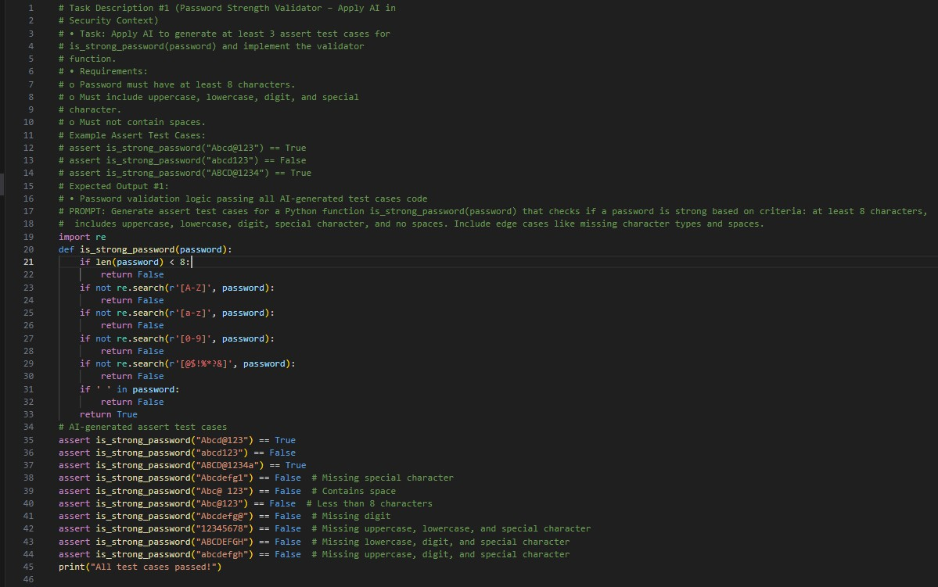
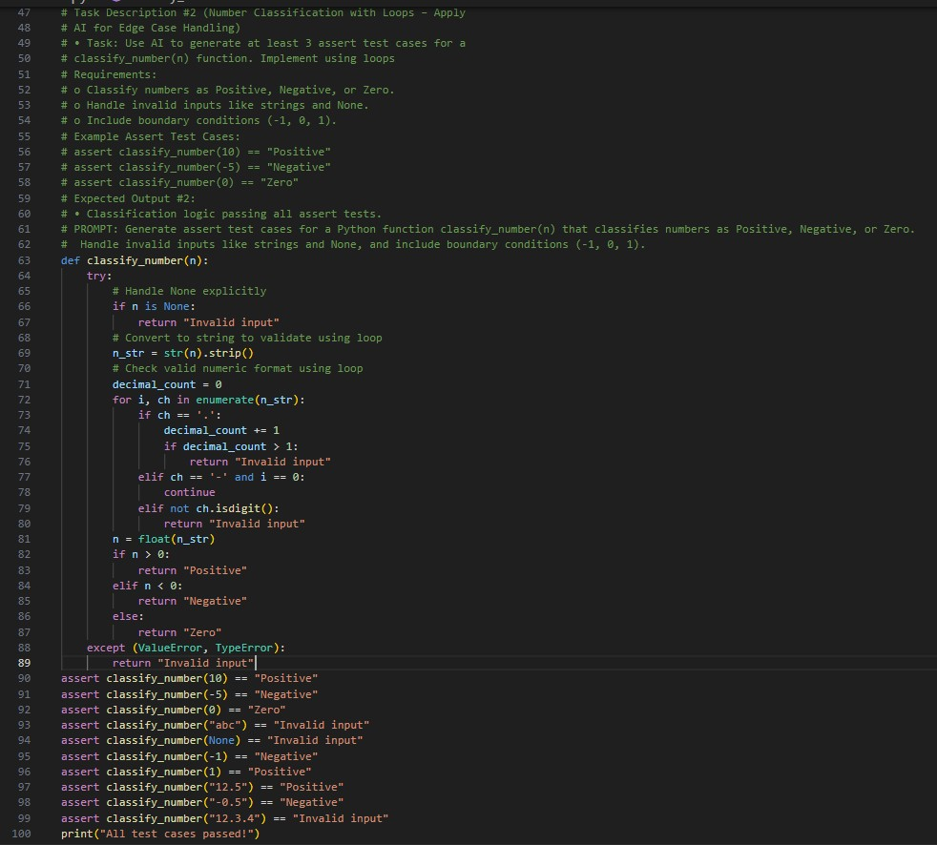

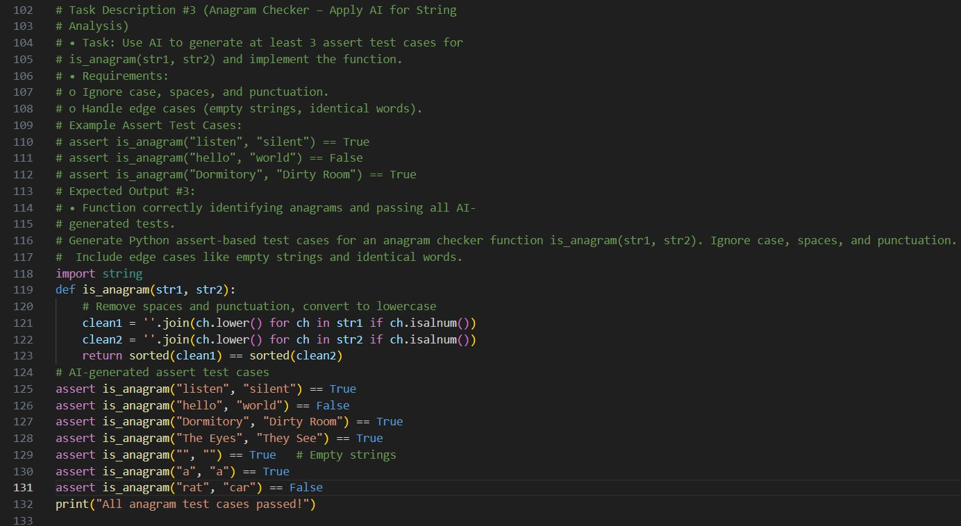

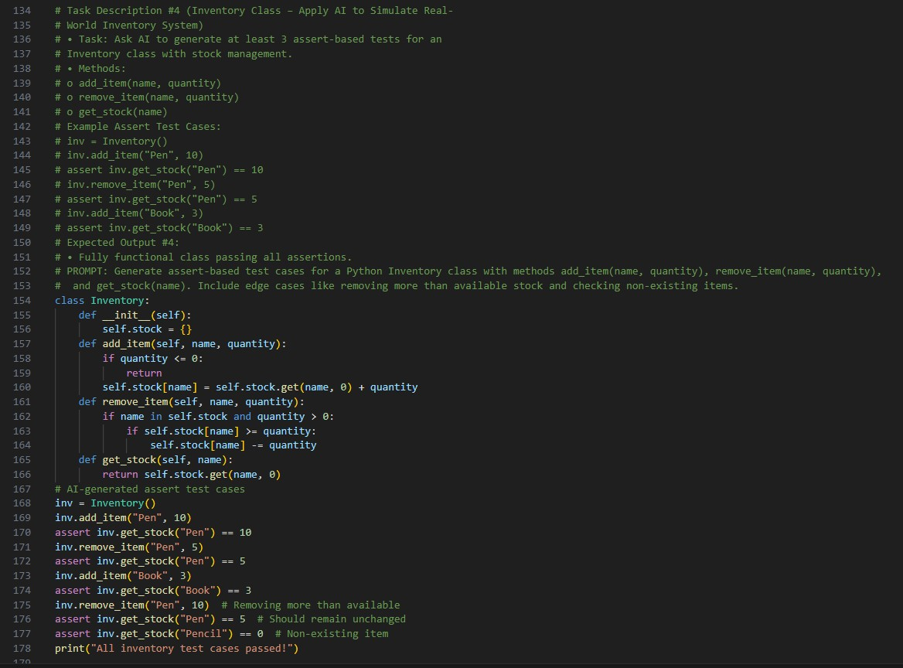

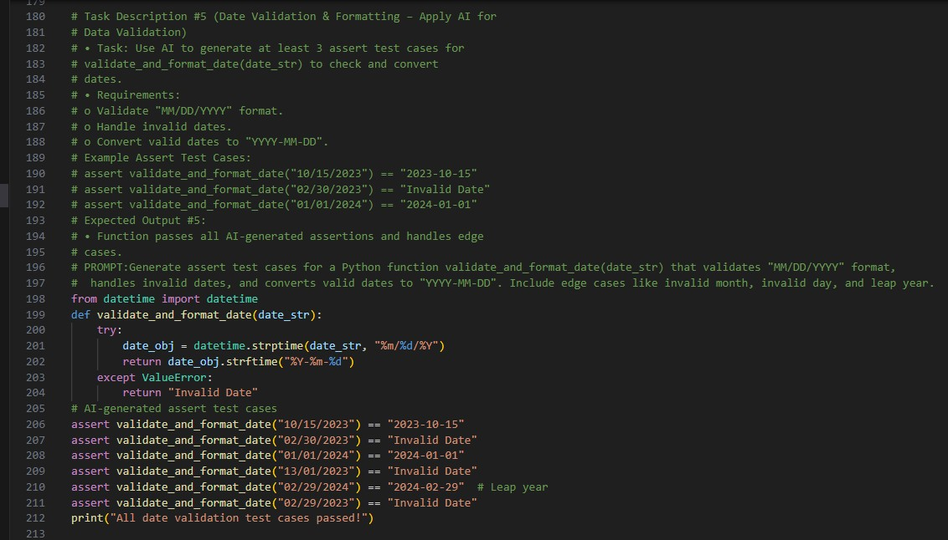

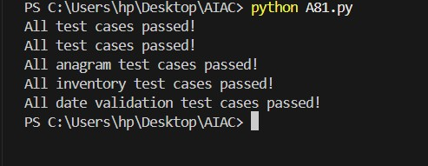

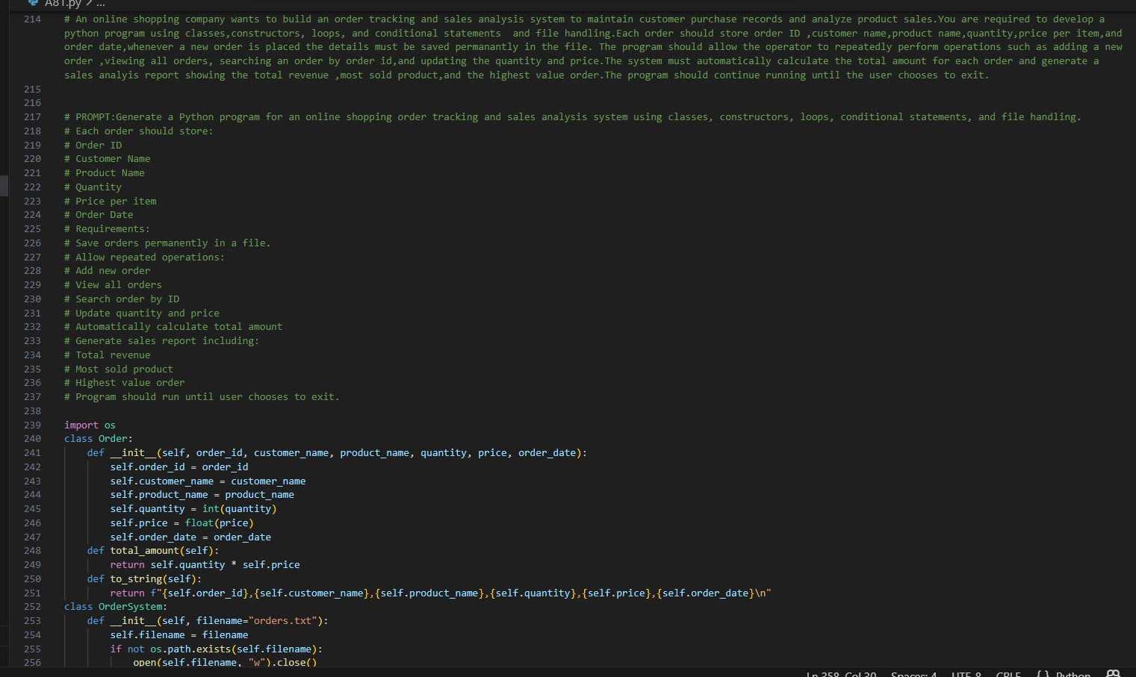
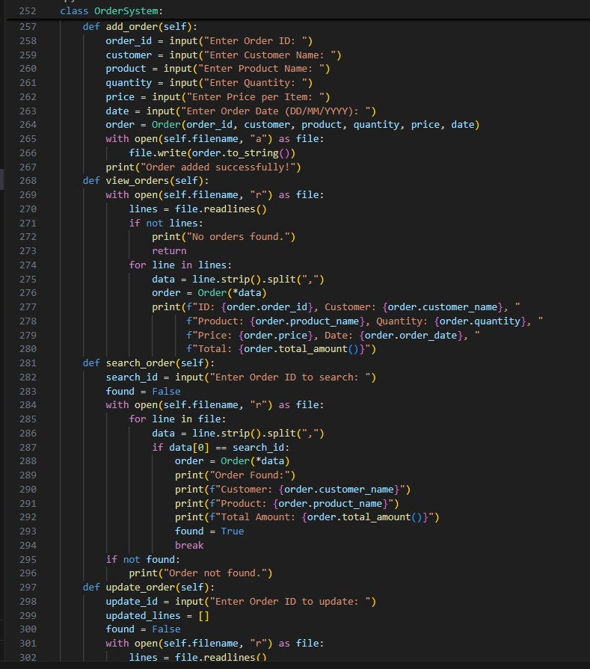
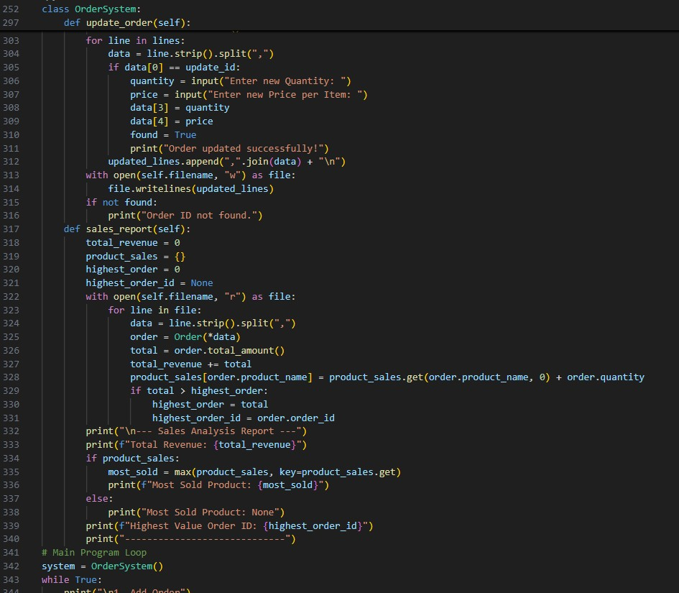

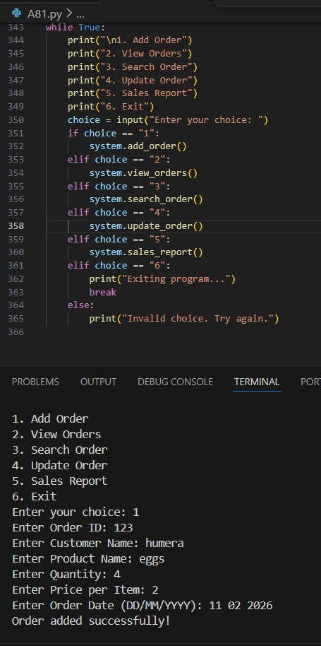
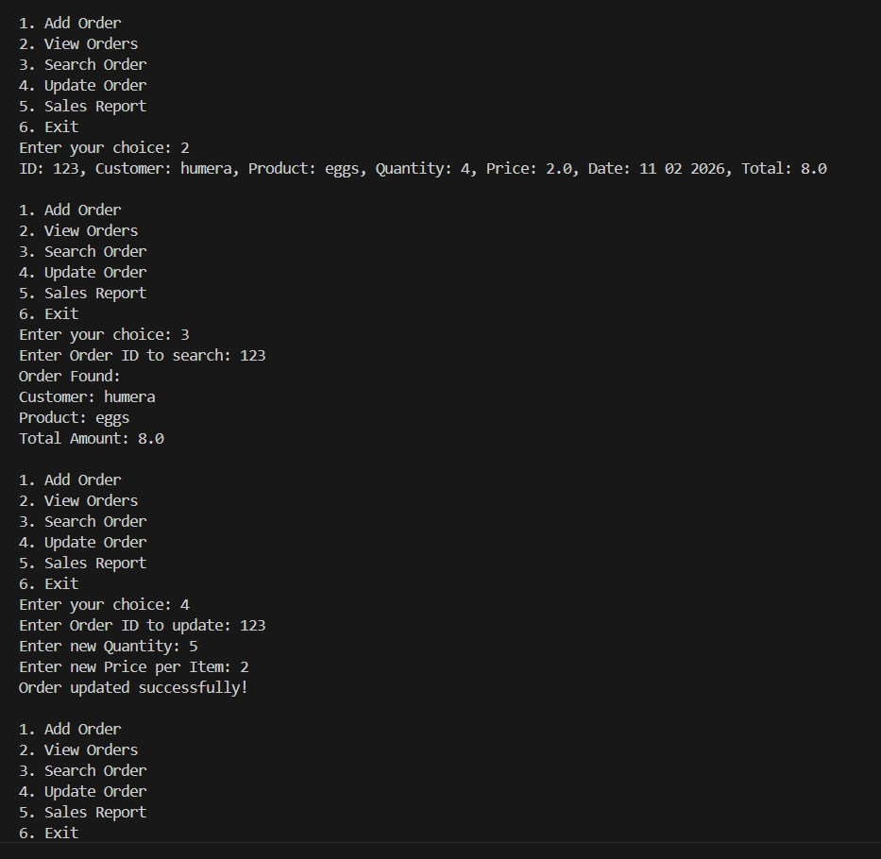

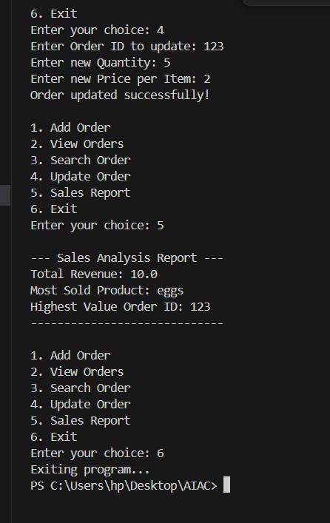

ANALYSIS:
#Task 1 – Password Strength Validator
This program checks whether a password meets security requirements like minimum length, uppercase, lowercase, digit, and special character. Regular expressions are used for validation. Edge cases like missing characters and spaces are handled. The function passes all assert test cases.

#Task 2 – Number Classification
The function classifies a number as Positive, Negative, or Zero using conditional statements. Exception handling is used to manage invalid inputs like strings and None. Boundary cases (-1, 0, 1) are tested. All assertions are successfully passed.

#Task 3 – Anagram Checker
This program checks if two strings are anagrams by ignoring case, spaces, and punctuation. It cleans the strings and compares sorted characters. Edge cases like empty strings and identical words are handled. The function passes all test cases.

#Task 4 – Inventory Class
The Inventory class manages stock using object-oriented programming. It supports adding, removing, and checking stock using methods. Conditional logic prevents negative stock. All assert-based tests are successfully validated.

#Task 5 – Date Validation & Formatting
The function validates dates in "MM/DD/YYYY" format using the datetime module. It converts valid dates to "YYYY-MM-DD" and handles invalid dates using exception handling. Leap year cases are also considered. All test cases pass correctly

#Task 6 – Order Tracking & Sales Analysis System
This program uses classes and file handling to store and manage order records permanently. It supports adding, searching, updating orders, and generating sales reports. The system calculates total revenue, most sold product, and highest value order. The program runs continuously until the user exits.

